Notes From Barb’s Interview:

Dated: March 30th, 2015

NOTES:

I talked to Barb about the problems we were facing with the video presentation. Apparently in the video, the video, the subject blocks the flash sets that show the pictures. However the audio is still very well audible and the viewers have a fairly good idea of what this video is about. Our main goal was to ensure that the viewers can see the template with the answers, pause the video, answer the question, record the response and instantaneously know if the answer is right or wrong.

After talking to her, we came to the final conclusion.

RESPONSE C

RESPONSE B

RESPONSE D

RESPONSE A

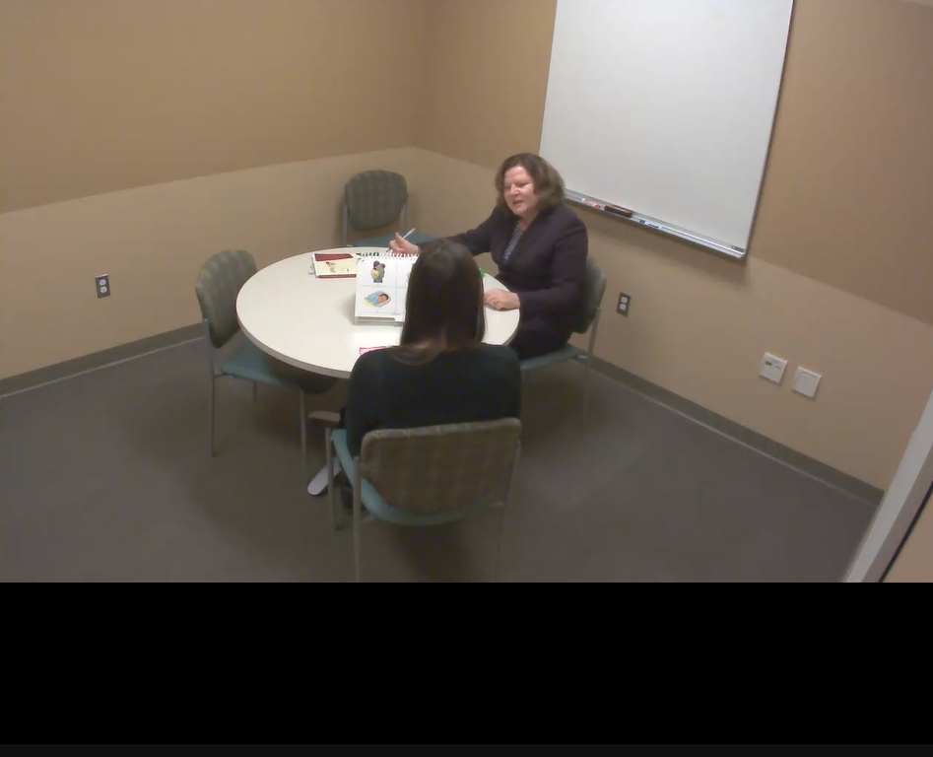

Once the administrator asks a question, the video will pause and a pop up box will appear with the picture that resemble the options that the subject in the test is seeing. The response will be recorded and a dialog box will appear to show if the response is right or wrong.

At the end of the set, the total number of responses will be recorded. If the subject reaches the ceiling of 8 responses, then they redo the set. If not, then they have the option of either retaking the exam or moving on to the next set.